ZUG Installation Guide(Linux)
Whilst all reasonable care has been taken to ensure that the details are true and not misleading at the time of publication, no liability whatsoever is assumed by Automature LLC, or any supplier of Automature LLC, with respect to the accuracy or any use of the information provided herein.
Any license, delivery and support of software require entering into separate agreements with Automature LLC.
This document may contain confidential information and may not be modified or reproduced, in whole or in part, or transmitted in any form to any third party, without the written approval from Automature LLC.
Copyright © 2010 Automature LLC
All rights reserved.
Revision History
Ver. | Date | Name | Description of Changes
1 | 2011-01-05 | Sankha | First Edition
Content
Table of Contents
1 Introduction 4
1.1 Document Purpose.....................................................................................4
1.2 Intended Audience.....................................................................................4
2 System Requirements 5
3. Installation Instructions 6
3.1 Zug installer download..............................................................................6
3.2. Initialization of Zug installation...............................................................6
3.4 Completion of Installation.........................................................................7
3.5 Version Verification....................................................................................8
4. License Activation 9
5.How to activate Built-in Atom Library 10
6. Uninstalling Zug 11
7.Troubleshooting the Installation 12

1 Introduction

Zug is Automature’s software test automation tool. Zug provides an execution environment for tests specified using CHUR. Zug can be run on any environment that supports the Java Runtime Environment.

1.1 Document Purpose

The installation guide walks you step-by-step through installation of Zug. It gives troubleshooting information for installers. Once you install the tool, you can execute automated tests written in the spread sheet based Chur automation language. To get further information refer ZUG Forum and can be found in the installation directory as ZUG Release Notes.txt

1.2 Intended Audience

This is intended for people who would be running test-cases written in Chur on Zug execution environment. Zug results can be further integrated with Zermatt.

2 System Requirements
Before running ZUG on a computer, it has to meet some basic requirements:
Operating System – Ubuntu 10.4 or higher
Software – Java
- Java(TM) SE Runtime Environment 1.6 for Linux
http://www.oracle.com/technetwork/java/javase/downloads/index.html
or
You can download and install in Ubuntu using the command
sudo apt-get install openjdk-7-jre

3. Installation Instructions

3.1 Zug installer download

- Download the Setup of the latest ZUG package from the Automature FTP site. Please fill up contact information form if needed.

3.2. Initialization of Zug installation

- Open terminal then go to the folder where you have downloaded the latest ZUG package.

Type these commands
  - cd <the downloaded directory>
  - sudo sh <ZUG Installer file name>
As for example
    - cd /home/dave/Downloads
    - sudo sh ZUG_INSTALLER-1.0
You will see the following output as shown below.
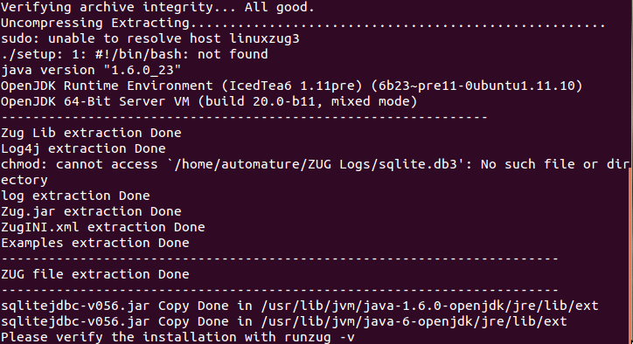
This is a shell executable file which will copy its required files and folder by providing the permissions. To verify the installation type in terminal runzug

- If you face any problem during the installation kindly look into the 7.Troubleshooting the Installation Chapter, else contact us at support@automature.com.

3.4 Completion of Installation

- The following screen will appear once the installation is complete. This means that Zug can be run from anywhere in the command prompt window, one does not need to be in the Zug directory.
- Kindly email the file Config.txt (which is created automatically in your Zug folder) to sales@automature.com to receive the copy of license for Zug ( not for trial version).
The Config.txt is a simple text file with the following information :

Physical Address:
*
-----------------
Expiry Date:
2012-01-31
-----------------
Company Name:
ABCD Inc.
-----------------
Contact email:
yourname@youremail.com
-----------------
IP Address:
127.0.0.1
-----------------

3.5 Version Verification

- Open a new terminal window and type: runzug –version or runzug -v.

This is to verify that the correct version of ZUG has been installed. The version number displayed should match the version number of the package that you downloaded but it will show only if the Licence is activated.
It promts for No License.key as shown in the following screenshot.

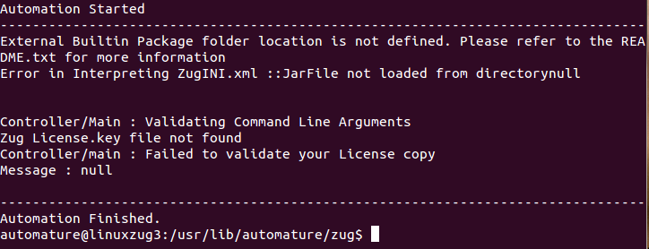

4. License Activation

Once you have successfully installed Zug in your machine, you will have to activate your
License in order to use Zug.

Steps to activate your license:
- Download the file Zug license.key, which is provided to you in the email address which you had given in your contact information.
- Place the file in the Zug folder where you installed which is $ZUG_HOME in your env.

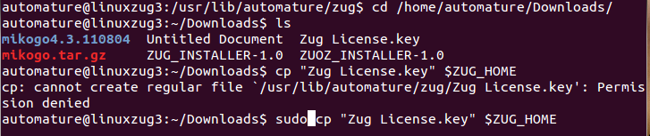

After Putting the file in the directory it can be checked that what is its version.

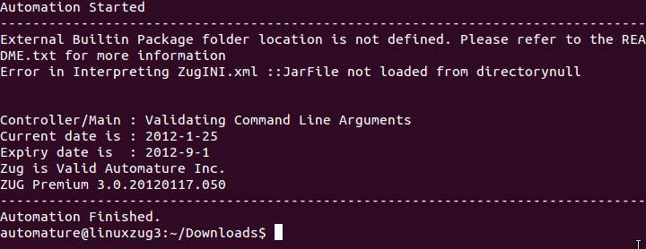

5. How to activate Built-in Atom Library

Zug is designed to be user-extensible with plugins, also known as built-in atoms, to deliver additional functionality that target domain specific behavior. Examples of such extensions are atoms that allow testcases to be written to drive web applications by interacting with browsers. Such atoms must be deployed as Java packages (i.e. Jar files), that implement the required interfaces. The recipe for developing custom built-in atom libraries for Zug is described in the Chur Programmers Guide.
After deploying the built-in atom library, the library must be activated, so that Zug can recognize the atoms that are part of the deployed package. This is achieved by editing zug.ini, which is an XML file, defining behavioral attributes for Zug. Each built-in package is described using a <builtinpackage> section, shown below. Zug allows several such packages to be configured. Example of such a package is Zuoz atoms.

After installation of Zuoz you will see the following screen.
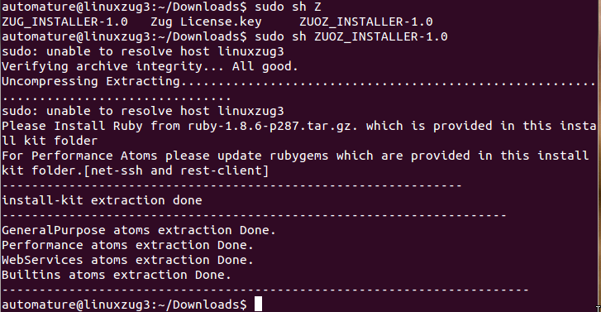

However to activate Zuoz you need to edit the Zugini.xml in the Zug installation directory located at /usr/lib/automature/zug.
You need to edit the following lines:
<builtinpackages>
<builtinpackage name="Zbrowser">
<file-path>/usr/lib/automature/zuoz/Atoms/Builtins</file-path>
<jar-package>com.automature.zuozbuiltins.zbrowser</jar-package>
<class-name>BrowserOperation</class-name>
</builtinpackage>
</builtinpackages>
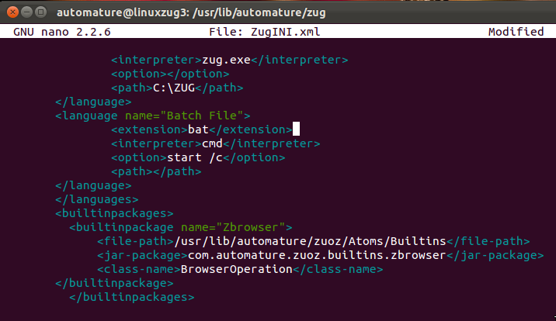

6. Uninstalling Zug

- To uninstall zug from your System
  - Open Terminal
  - Go to folder location where zug is installed
    - cd $ZUG_HOME
  - Type the command
    - sudo sh uninstallZug

- Zug will be uninstalled automatically with removing all the dependency.

7.Troubleshooting the Installation
If you see the following errors do the following:
- The prompt appears after installing Zug and trying to check the version of Zug.
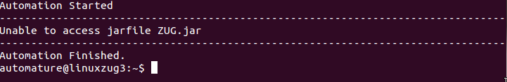
To resolve this error, type the following as stated below in the Terminal.
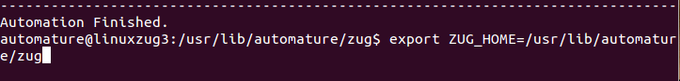
- License key not found in proper place

Solution: The license key given to you by email needs to be placed in the folder where Zug is installed. Kindly have a look at the License Activation topic.

- ZugINI.xml configuration
Zug3.0 version now can call the external java jar files as builtin atoms through chur spreadsheet. To make it happen the ZugINI.xml parsing is need. Inside the Zug installation directory the ZugINI.xml file can be edited to by putting the values in the tags of
<builtinpackages>
<builtinpackage name="">
<file-path></file-path>
<jar-package></jar-package>
<class-name></class-name>
</builtinpackage>
</builtinpackages>
if no value is written then it will show a warning message while running the ZUG automation.
The Zug installation directory is normally /usr/lib/automature/zug
- For further problems visit ZUG Forum.

